Chapter 8, Solution 20.

For t < 0, the equivalent circuit is as shown below.
2 Ω
+ −
30
− +
v_{C}
i

v(0) = –30 V and i(0) = 30/2 = 15 A

For t > 0, we have a series RLC circuit.

- = R/(2L) = 2/(2x0.5) = 2

ω_{o} = 1/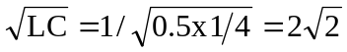

Since α is less than ω_{o}, we have an under-damped response.

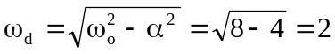

i(t) = (Acos(2t) + Bsin(2t))e^{-2t}

i(0) = 15 = A

di/dt = –2(15cos(2t) + Bsin(2t))e^{-2t} + (–2x15sin(2t) + 2Bcos(2t))e^{-αt}

di(0)/dt = –30 + 2B = –(1/L)[Ri(0) + v_{C}(0)] = –2[30 – 30] = 0

Thus, B = 15 and i(t) = (15cos(2t) + 15sin(2t))e^{-2t} A

